Hello, thank you for using the Snap-On Power Tools Test Viewer. This software was developed by Jackson Bothmann, an intern in the Power Tools group, for use in the Snap-On Tools Kenosha location. It is designed to be able to interface with a Test Manager server. More information is provided by the tutorial included with the Test Manager distributable, or by your Test Manager administrator.

**Installation:**

Place the entire directory (the folder that contains this file) into a location of your choice. Program Files is the most appropriate place. Note that adding and editing files in the Program Files directory requires administrator privilege. This keeps the files that the application depends on safe. However, almost any location will do.

Launching the application is as simple as running Test Viewer.exe. You will probably want to make a shortcut to the application in an easy to find place, like the desktop or the start menu.

**Startup:**

Upon launching the program, the user will encounter a mostly empty window. At the top of the window, there are a few dropdown menus which contain options to setup the application. The center of the screen is where stations will be visualized.

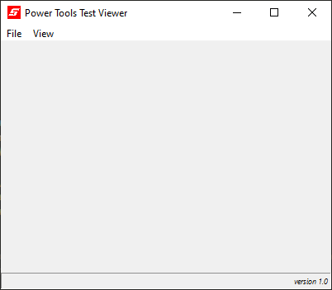

-Configuration Controls

-Data Viewer

-Broadcast Controls

**Connect to Server:**

To begin, navigate to File – Change Server Address. A small Dialog will appear, prompting you to enter a url. You can obtain the url from the Test Manager’s Connections dialog, or from your Test Manager administrator. Select Save to connect to the server

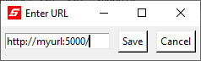-URL Entry

-Save Button

**Add Station:**

To add a station to the viewer, navigate to View – Select Station. A dialog will appear which lists all available stations from the server. For example, the Test Manager that I am connected to has one station. The station is numbered 2, and has a title of “Bolt Rundown”. Check the station or stations that you would like to view, and select Save.

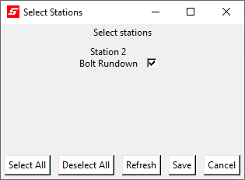

-Station Information

-Checkbox

-Save Button

This dialog also gives the user a convenient way to quickly select all or none of the available stations. Selecting Refresh will update the list to include the most recently available stations.

**Clear All Stations:**

If the user desires to remove all stations from the screen, navigate to View – Clear All Stations.

Once a station has been added, the station will appear on the main screen. For example, here is an example of a viewer with one station added. This station has four different cycle counters, representing three different test fixtures and their sum, and an indicator of which fixture is currently in operation. There is also a status indicator that shows whether the station as a whole is running or not. This information will automatically be updated by the server. Each station display has a few useful buttons: The pages icon will copy the station’s data to the user’s clipboard, and the Show Controls button will bring up the control dialog.

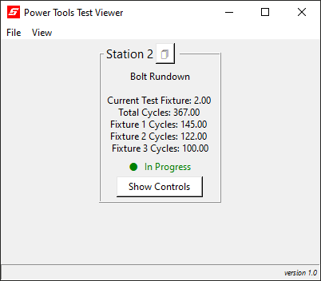

-Station Number

-Station Title

-Copy button

-Station Data

-Station Status

-Pause/Resume button

and Controls button

**Show Controls:**

In addition to the data that the Test Manager collects, there are also a number of control switches attached to each station. This menu can be accessed either through the Show Controls button on each station’s display, or via View – Show Controls. The desired station can be selected using the dropdown. The user is shown a list of 32 items. Each item shows the number of the control switch, a title, and whether the control is currently on or off. Test Viewer users cannot flip these switches, but they can view their status at any time. In this example, controls 1 through 4 have been designated as individual enable switches for the stations four test fixtures. All four switches are currently turned off.

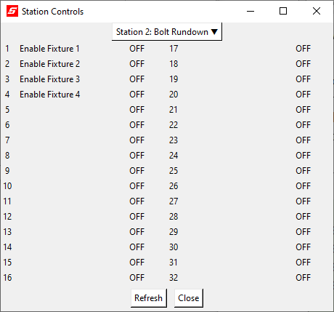

Selecting Refresh will update the dialog to show the most recent values of the controls.

**Write To File:**

It may be useful for the user to create a simple text file output representing the current state of their stations. If this is the case, navigate to File – Write To File. The user may select which station they would like to be represented on the text file. Once the user has made their selections, they may select Save As to open a system dialog prompting them to create a new *.txt file.

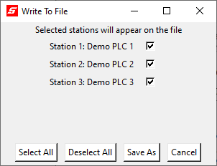

The new file will include a header which gives the date and time that the file was created, and a section with each selected station.

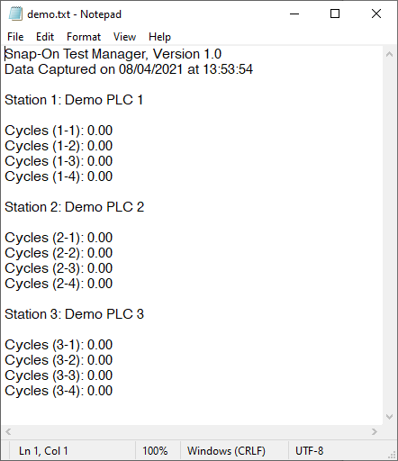

-Header

-Station Info

**Themes:**

The Test Viewer application can be visually configured to the user’s liking. Navigate to View – Theme. From this dialog, the user can select a color theme for the software, the font for all text, and the size for all text.

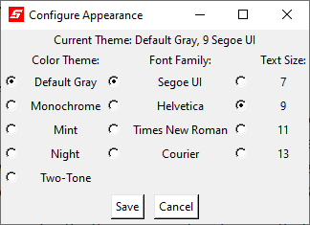

The application’s default values are shown selected here. It is left to the user to find an appearance that suits them.

Tip: Courier is a monospaced font. If there is cut off text anywhere in the application, it may help to set the font family to Courier.

Test Viewer is distributed with five themes, four fonts, and four text sizes. More may be added through the use of configuration files.

**Configuration Files:**

The Test Manager application uses the contents of three *.JSON files to configure itself upon startup. Edit these files with your favorite text editor to modify this behavior to your liking. Make sure that these files use proper JSON formatting. If the Test Manager directory is in a protected space, like Program Files, the text editor must be run as administrator to make changes.

**config.json**

This file is structured as a JSON object with the following attributes:

“url”: Set this as the URL of a Test Manager server, and Test Viewer will automatically connect to that server upon startup. This must be a string.

Set as null if you don’t want this behavior.

“addAll”: Set this as true to automatically add all available stations when connecting to a Test Manager server upon startup. Set as false if you don’t want this behavior.

Does nothing if “url” option is null

“theme”: Set this as the title of an installed theme to use it upon startup.

This must be a string. Installing themes is explained in the themes.json section

“fontFamily”: Set this as a name of a font to use it on startup. String.

“fontSize”: Set this as a number to use that text size. Integer.

**fonts.json**

This file is structured as a JSON object with the following attributes:

“families”: an array of fonts names to be added to the theme menu. Strings.

“sizes”: an array of font sizes to be added to the theme menu. Integers

**themes.json**

This file is structured as an array of JSON objects, each representing a theme to install.

Each theme item has the following attributes:

“title”: The name of the theme. Must be a string.

“bg”: The background color of most elements. Must be a string containing a valid color.

“fg”: The text color of most elements. Must be a string containing a valid color.

"selectbg": The background color when highlighting text or selecting a button.

Must be a string containing a valid color.

"selectfg": The text color when highlighting text or selecting a button.

Must be a string containing a valid color.

"contrast_bg": The background color of interactive elements, like buttons and entries.

Must be a string containing a valid color.

"contrast_fg": The text color of interactive elements, like buttons and entries.

Must be a string containing a valid color.

"contrast_selectbg": The background color of interactive elements when selected.

Must be a string containing a valid color.

"contrast_selectfg": The text color of interactive elements when selected.

Must be a string containing a valid color.

Valid Colors:

-A hexadecimal color code, preceded by a number sign, and containing either three, six, or nine hexadecimal digits.

-A color named by the [X11](https://en.wikipedia.org/wiki/X11_color_names) format

**This concludes the tutorial.**

**Thank you again for using Snap-On Power Tools Test Manager.**